Weyland Bulletin – July 2026
Summer party and a busy quayside
Noah Fischer · 26 July 2026
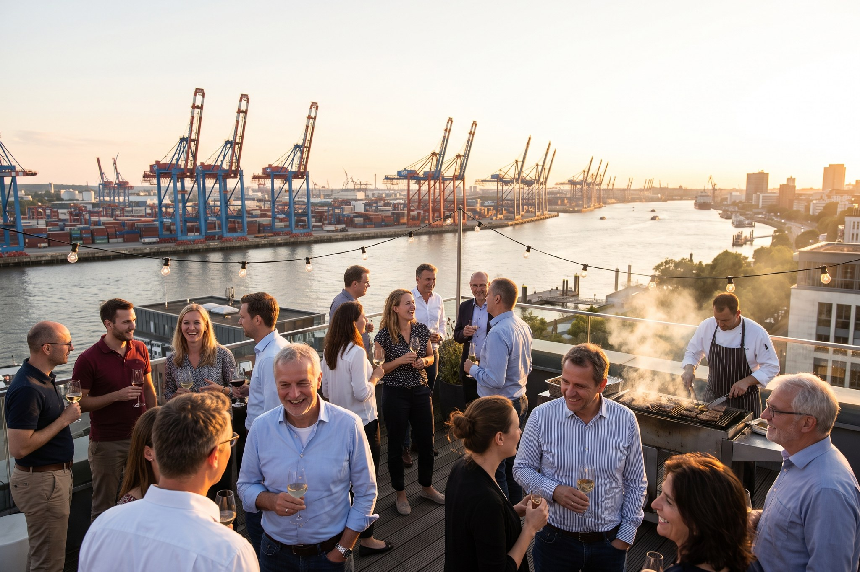

Summer party and a busy quayside
More than 300 colleagues celebrated at Am Sandtorkai on 26 June, while the team in Eastholm kept the foundation campaign going.

Project update
Project | Status
Harrow Bay | 8 of 40 monopiles installed by the end of July
Kestrel Ridge | 11.9 GWh generated in June
Millbrook | Application MDC/2026/0412 under consideration
Fenwick | Grid application submitted in July

Also this month: Severn Subsea Cables told us on 21 July about a factory test failure on export cable 2. Elena Márquez explains in a short video what this means for the schedule – in brief: cable 2 arrives around eight weeks later; first power remains planned for 2027.

People
Thank you to everyone who volunteered at the Harrow Bay beach clean – 46 bags of litter collected.
Weyland Bulletin is sent to 3,800 subscribers. Unsubscribe at any time.

